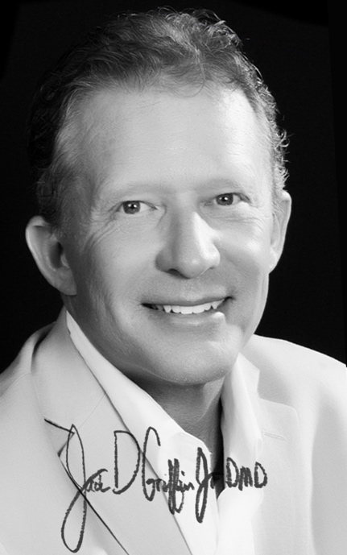
Educate. Engage. Encourage.
Inspiring clinical excellence to empower your practice.
Dr Griffin has the unique experience of being in a large fee for service practice for over 25 years along with owning multiple practices in the corporate dentistry world. He understands the complexities and potential of both and is passionate to share what he has learned about clinical treatment and practice philosophy.

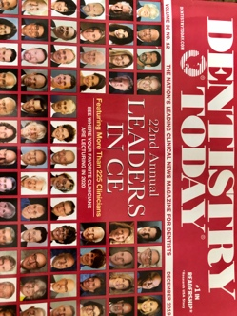
Enthusiasm about dentistry is contagious in Dr Griffin’s courses and he is a humble, entertaining teacher. Jack has been honored to have shared with thousands of dentists on subjects that all center around practice efficiency and renewing your passion for dentistry. Comprehensive, comfortable, highly aesthetic dentistry is emphasized.

Distinctions are numerous including earning Diplomate status with the American Board of Aesthetic Dentistry (ABAD), Accreditation in the American Academy of Cosmetic Dentistry (AAACD), Masters in the Academy of General Dentistry (MAGD), and Fellow International Academy for Dento-Facial Esthetics (IAD). He has been published over 50 times, is a Clinical Director for the Pacific Aesthetic Continuum, and has contributed to product development/review with manufacturers and periodicals.

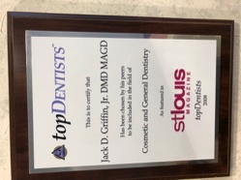
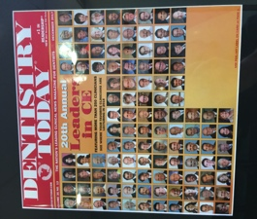
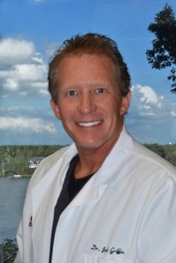
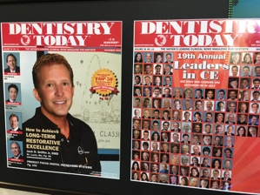
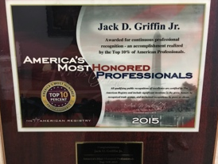
Dr Griffin has been chosen one of the “Leaders in CE” for many years, has been chosen as a “Top Dentist” in St Louis, and one of “America’s Most Honored Professionals” many times. Some of his lecture topics include regenerative materials, comprehensive aesthetics, cementation and adhesion, digital CAD/CAM dentistry, digital photography, and passion for practice. Jack knows has been blessed to be surrounded by those who make the dental experience both rewarding and enjoyable and is thankful to those who have invested time to laugh and learn with him.
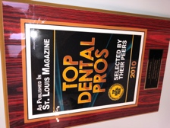
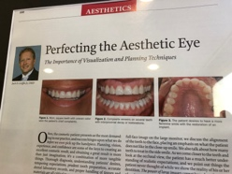



Course descriptions
What follows are brief descriptions for some of the courses Dr Griffin teaches. Jack is happy to customize of course programs to fit the needs of your group and does interactive lectures, participation courses, live patient demonstrations, and in office consultations. Please visit
www.MyGreatSmile or email jgriffinjrdmd@gmail.com to book speaking excellence.
Thank you very much.
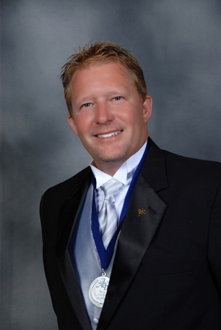
Jack D Griffin Jr DMD
Diplomat American Board of Aesthetic Dentistry
Accredited American Academy of Cosmetic Dentistry
Master Academy of General Dentistry
Fellow International Academy of DentoFacial Aesthetics

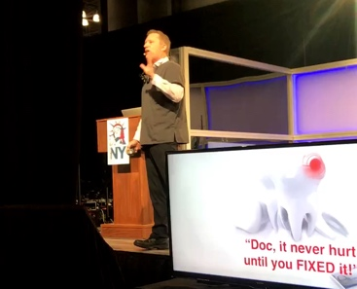

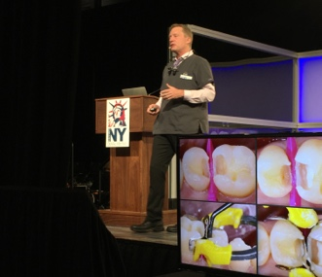
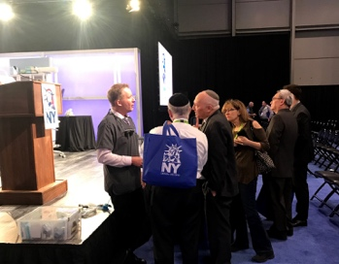
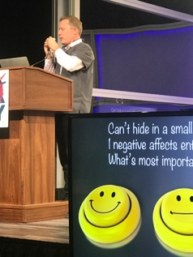

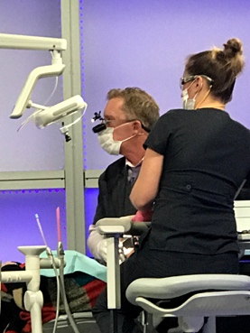

A world of heightened cosmetic awareness
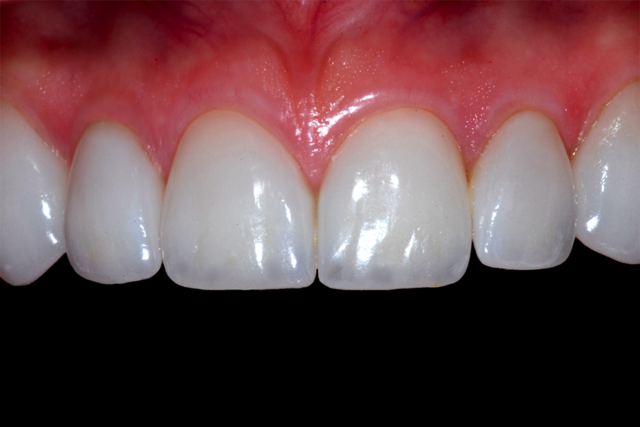
The Pacific Aesthetic Continuum
Comprehensive dentistry, aesthetically driven.
Jack D Griffin, Jr DMD MAGD
Format: Lecture and participation
Half, full day, half day workshops
Doctors, clinical staff

Educate. Engage. Encourage.
In this day of heightened cosmetic awareness, we are held to higher cosmetic standards than at any time in dental history. Often the choice in materials, preparation styles, temporization, and lab communication can lead to confusion, stress, and less than ideal results. How do we restore the worn dentition? How do we open the bite? How do we determine tooth length? All important decisions for comprehensive therapy today. The focus for this course is an overview of what techniques are taught at the Pacific Aesthetic Continuum and steps doing each case from planning, to preparation, to placement. We will take. This program is intended for any dentist or staff interested in maximizing office efficiency and taking the stress out of the stress out of the more comprehensive, aesthetic cases.

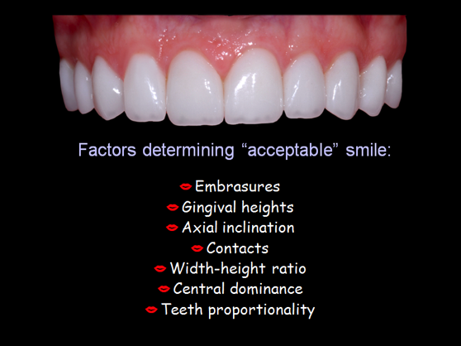
The format will be a high energy, interactive lecture going through many actual clinical cases. The emphasis will be on anterior/cosmetic cases but we will also discuss choices in posterior tooth colored indirect restorations that are giving us more success than any restorations since gold. Cases will be taken from planning, mock up, preparation, impression taking, temporization, lab communication, and cementation. Our goal is to take the anxiety out of each of these steps and to increase your efficiency with these materials. We will review cases where things didn’t work out so well and what to do when these problems arise. This is a comprehensive course covering current concepts in esthetic restorative materials to use in any cosmetic and general dentistry practice…what works today!

Lecture outline:
- Understanding the basics of smile design, the cosmetic case planning and presentation
- Tooth wear…it’s causes and reconstruction
- The mock up, records, bite registration, and alignment aids for great lab communication
- The most durable aesthetic materials EVER: lithium disilicate, zirconia, pressed ceramics
- Preparation for success … conservative aesthetic preps, when to be aggressive when to “no-prep”
- Steps is insure luting/cementation success… what and how to use for long term durability
- Photography basics for marketing, case acceptance, documentation, and lab communication

“Doc, it was never a problem until you fixed it!”
Simplifying bioactive/regenerative dentistry….from prevention to perio to porcelain

Jack D Griffin, Jr DMD MAGD
Format: Lecture and participation
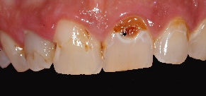
Half or full day and half day workshops
Doctors, clinical staff
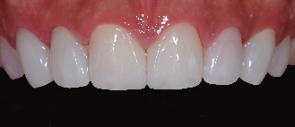
Doc, that tooth never hurt until you “FIXED” it. Certainly, you’ve done a restoration on an asymptomatic tooth only to create a tooth that was cold sensitive or that the patient couldn’t bite on. Have you had a patient come in carrying in their hand that crown and post you just placed a month ago? We all have.

Stress in the dental office happens when thing just don’t go as well as planned. Was it the material, technique, or just the patient? Today there is a myriad of newer restorative materials and techniques with seemingly endless choices in adhesion, cements, composites, ceramics and graft materials… could this stuff be any more confusing? They key is having an arsenal that is predictable, almost universal in application, and comfortable. When do we etch, bond, cement, rinse, blow, cure, drill, sand blast......? Let’s stop the madness.

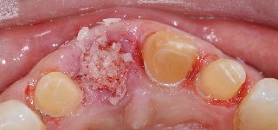
The goal of this course is to simplify every day, real practice dentistry and do it with great efficiency and predictability. This comprehensive course will cover both direct and indirect restorations with the latest regenerative materials and techniques that all practices can benefit from. We will not waste tome talking about procedures dental practices seldom do, but learning to enjoy practice more with repeatable, patient pleasing success using

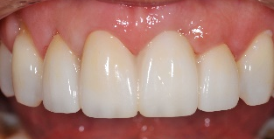
BIOACTIVE/REGENERATIVE dentistry in everything from perio to We will cover many topics including perio, prevention, direct and indirect CAD/CAM that can provide the most biofriendly, long lasting restorations ever. We will learn how to do it right the first time and to make the practice more enjoyable and efficient.

Learning objectives:
- Regenerative Direct Dentistry… newer regenerative/bioactive direct restorations with great contours, contacts, and comfortable aesthetics
- Regenerative cementation … The most durable indirect esthetic restorations EVER. From planning, to preparation, to placement with CAD/CAM, lithium disilicate, and zirconia…both simple and complex.
- Tooth replacement…planning for success with socket preservation, bridges, and implants
- Comprehensive aesthetics…Taking biofriendly principles to the front of the mouth, every day cosmetics and the foundations for success.
- Realizing the ULTIMATE GOAL…happier patients, happier dentist.

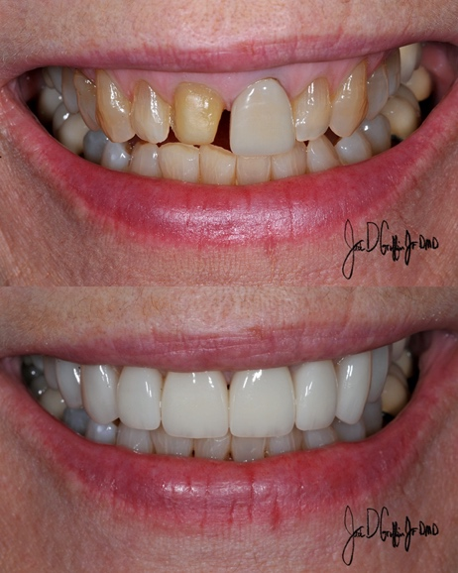
“My-selfie and I” (reducing the patients’ need to filter themselves)
Photography, treatment and the heightened aesthetic awareness

Jack D Griffin, Jr DMD MAGD
Format: Lecture, participation, or both
Half, full day, or half day work shops
Doctors, all staff

The selfie may be the best patient motivation tool in the history of dentistry. Because patients see themselves in photos and often don’t like what they see, dentistry can provide the solutions for them.

From the dental office point of view, photography today is the basis for our marketing, social media, in office patient awareness, case acceptance, documentation, and our development as a cosmetic provider. In this day of heightened cosmetic awareness, we have more opportunity and are held to higher cosmetic standards than at any time in dental history. Great photos should be routinely used to plan, prepare, evaluate, and correct our cosmetic cases.

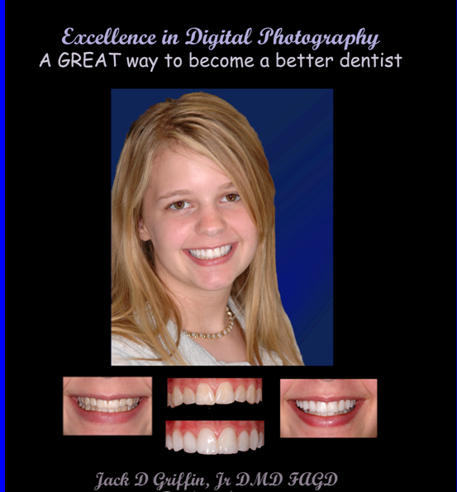
This course features the utilization of photography into every aspect of dentistry today. We will discuss how to capture and use digital images in all parts of the practice from the patient consultation, case planning and delivery, to marketing and practice promotion. Emphasis will be placed upon separating yourself from other clinicians by your case documentation, development of the office portfolio, a great web site gallery, and what images to take to help the patient accept the cosmetic work you want to do.

You will have fun learning all of this by going through many clinical cases from start to finish and the photography used to make it all happen for cases from single tooth porcelain matching to complex restorative/cosmetic cases. The basics of great portrait photography will be demonstrated while emphasizing how to capture the emotion needed to have other patients ask for your cosmetic expertise. Dr Griffin brings the equipment he uses every day in practice and shows efficient and predictable ways of achieving excellent results. For participation courses, it is encouraged (but not mandatory) for participants to bring the equipment they normally use for help with set up and capturing techniques. This is the course you need to obtain consistent, high quality images.

Lecture outline:
- The basics of digital photography equipment and what buttons to push
- Mastering the basic images – consistent series for all applications from Instagram to lab communication
- Cosmetic treatment - planning, prepping, and perfecting cosmetic cases
- The portfolio - excellent photography to market…having patient WANT dentistry you like to do

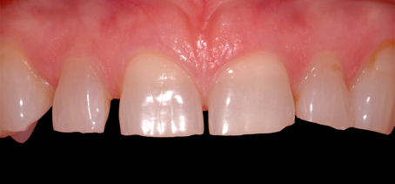
Let’s Grow Tooth
Regenerative bio-interactive restorative dentistry
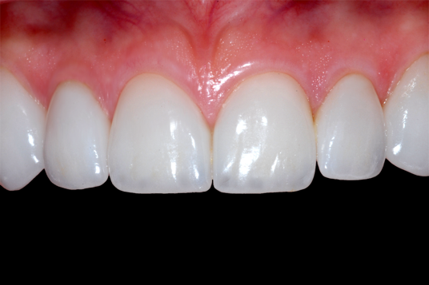
Jack D Griffin, Jr DMD MAGD
Format: Lecture and participation
Half day lecture or workshop
Doctors, clinical staff
(Often combined with “Let’s Stick Together” course)

Ever had a patient say “Doc, that tooth was never a problem until you fixed it”? Let’s stop the madness. Wouldn’t it be wonderful if we could make the tooth grow? With newer regenerative/bioactive materials we can stimulate dentin healing and self-repair in our direct and indirect restorations all while reducing sensitivity. These materials promote oral health by decreasing plaque, reduce bacterial accumulation, or promote cells to cause regeneration of tissues.

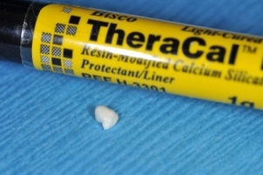
We will learn indications for newer liners, bases, cements, and restorative materials that encourage dentin repair, lessen sensitivity, and promote a healthier oral environment. We will apply these newer materials in our direct composite restorations while exploring matrix systems for predictable, tight, well contoured contacts and methods for efficient restorative dentistry. We will also explore regenerative materials for dentin replacement and cementation of durable esthetic indirect restorations like lithium disilicate and zirconia to reduce post operative problems and increase clinical success. We will learn how to do it right the first time and to make the practice more enjoyable and efficient.

Learning objectives:

- The bioactive/regenerative environment….why, how, and what materials.
- The latest in regenerative materials: liners, dentin replacements, cements, restorative materials to provide an environment where tissues can heal.
- The most durable indirect restorations ever: zirconia and lithium disilicate crowns formation and sealing of the restoration margins.
- Efficient direct composite placement – preparation, bonding, matrix selection, bulk fill and bioactive materials for long term oral health.
- Soft tissue optimization: lasers, medicament's, and other goodies for soft tissue excellence.

Cementation Sanity
Eliminating most of the confusion and problems with indirect restoration placement.
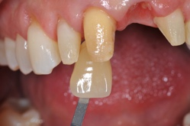
Jack D Griffin, Jr DMD MAGD
Format: Half day lecture or
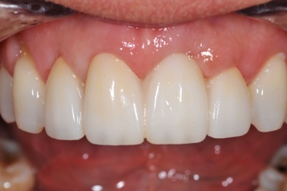
Half day workshop or both
Doctors, clinical staff
(Often combined with “Let’s Grow Tooth” or “Doc, that tooth never hurt until you fixed it” to make a full day course)

Leakage, breakage, de-bonding, sensitivity, staining……oh my! It’s a confusing dental world out there. When a restoration fails, was it the prep, impression, lab, or me? CAD/CAM or press, cement or bond, layer or monolithic, etch or no-etch, dry or moist, light or chemical cure......? Let’s stop the madness. Ever had a patient say “Doc, that tooth was never a problem until you fixed it”? Advances in durable tooth colored restorative materials means changes in preparation and cementation techniques. Our goal is to end the uncertainty with the newer materials and learn how to have the ultimate success with today’s indirect materials from planning to preparation to placement.

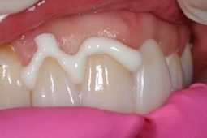
We will discuss the trendy durable indirect esthetic materials featuring zirconia and lithium disilicate while focusing on clinical efficiency and long-term success by discussing the prep, cementation, bonding, and adjustments. CAD/CAM dentistry will be featured as well as clarification of luting materials emphasizing materials and protocol for maximum strength and clinical efficiency. “Universal” bonding agents will be discussed and when to use them in the luting protocol for long term durability. With a myriad of newer restorative materials and seemingly endless choices in luting materials and bonding systems we will simplify things for predictable clinical success with the most durable indirect esthetic materials EVER. We will learn how to do it right the first time and to make the practice more enjoyable and efficient.

Learning objectives:
- The more durable indirect esthetic indirect materials…monolithic, maximum strength, acceptable esthetics, minimum effort, great preparations, and long-term clinical success.
- The classifications of luting materials, benefits to each and when to use…retention and restoration strengthening.
- Simplifying cementation choices – when to bond, when to cement, when to cure, what to use with focus on regenerative materials when the prep is good and maximum adhesion when needed.
- Review of digital impression techniques and the role of CAD/CAM dentistry. Does it fit your practice?
- The backbone of the restorative practice with posterior restorations and how to apply those techniques for the best, most durable anterior aesthetic cases, veneers, implants, and bridges.

Byte this …. the CAD/CAM restorative practice
Efficiency with digital impression systems and computer designed restorations

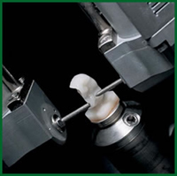
Jack D Griffin, Jr DMD MAGD
Format: Lecture and participation
Half day
Doctors, staff

Digital impressions and CAD/CAM restorations have become an everyday reality for modern dentistry whether lab or office made. Many dentists are trying to decide if going digital makes sense for them and how to incorporate the new technology into an efficient work flow. Current advancements make the decision much easier today. This course is intended to “de-mystify” the world of digital dentistry while reviewing various digital impression systems, restoration material selection, tooth preparation, and cementation for success.

In office CAD/CAM systems restorations have gained great momentum because of advancements in computer software and ease in design. Many restorations in the “early” digital years were less than excellent but quality, efficiency, and clinical success have increased dramatically rivaling many other materials used in aesthetics. In this course we will discuss which techniques and materials have been successful and which have not and how to incorporate digital dentistry into mainstream general practice.

This course is designed for those offices wanting to do the most current dental procedures in a very efficient way with an excellent service to the patient while trying to take the stress and guess work out of the newer esthetic materials. We will emphasize the procedures that give the greatest long term success. Digital dentistry is here to stay and we will help your office decide how committed to be in this digital restorative environment.

Lecture outline:
- Who should own a digital impression system and who should not
- The right questions to ask before buying
- A basic comparison of the more popular digital impressions systems
- To mill or not to mill?
- Lithium disilicate and zirconia…why, when, how
- Prep and placement for long term clinical success

