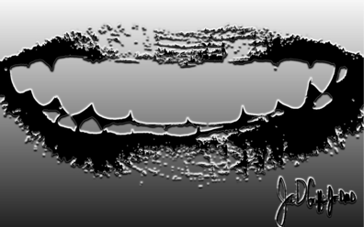
Post op Temporary Appointment

At 3-7 days post op:
- Document positive or negative remarks. “How have you been feeling? Anything rough or sharp to your tongue?”
- Reassure patient. ”The temporaries help protect the teeth and give you a chance to experience an approximation of what we are going to make your smile out to be. The temporaries are thicker, rougher, weaker, and not as natural as your final restorations will be. Also, these are all one color while your final restorations will have a more natural blend of colors and translucencies. We will adjust and polish them today and communicate any changes you want to the lab as they start to make them.”
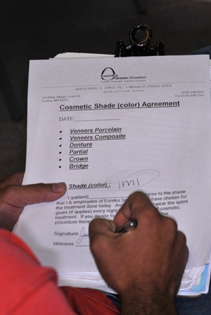
- Color verification. “How do you like the color? Are they too light or dark?” Let the lab know any requested changes and have the patient sign the “Shade and Shape” agreement. Stress that the final restorations will be smoother, thinner, stronger, and more natural in color. Normally we used a temporary color that we thought they wanted, but it’s still important that the color be verified. Often the temporary materials don’t match exactly one of the shade tabs so it’s nice to verify the temp color with the corresponding shade tab.
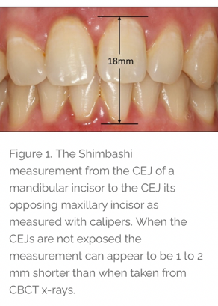
- Occlusion. “How does your bite feel? Are there any places hitting high? Does it feel like any teeth are in the way when you move your jaw around? Any pain in your jaws or increase in headaches?” Be positive and let them know that it’s common for the jaws to be sore after a long procedure when we did injections and had the mouth open for so long.
  - For rehab, full mouth, or bite opening cases: Check you desired Shimbashi measurement. Remember, compensate for laser tissue recontouring, any swelling that may be present around the temps, or preps that were done past the CEJ. If the number is considerably too high or symptomatic (patient too open), reduce occlusion. If the number is considerably too low or symptomatic, place composite on occlusal surface to compensate.
  - 3 pillars of occlusion…Simultaneous centric, cuspid rise, anterior disclusion: Use paper to check simultaneous posterior contact, cuspid rise when moving lateral, and that the posterior teeth move apart as the mandible slides forward.
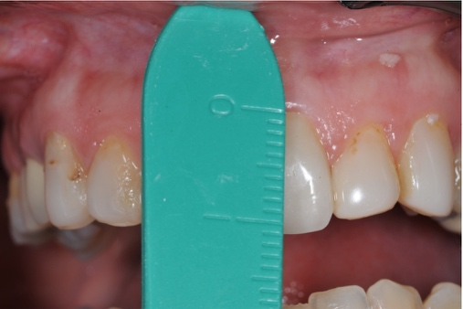
  - Adjustments: reduce or add where needed. If adding, bonding agent and a flowable that matches will usually be sufficient. More extensive modifications may require a more viscous composite.
  - Central incisor length: After all adjustments and polishing, take final verification measurement of the central incisor used for length verification (somewhere near 11mm). Record and take photo if different than what was recorded on the lab Rx.
- Shape. “How does the basic size and shape look to you?” I want to stress, this is mainly just to reassure the patient about how good the definitive restorations will look and not to spend a great deal of time adding and shaping the temporaries. Minor shaping (i.e. enhancing embrasures, shaping incisal edges, etc) is good along with running a fine composite rubber polishing cup or wheel over the labial and occlusal surfaces (like the Dialite system (Brasseler), One Gloss (Shofu), Enhance (Dentsply). Correct minor midline issues, cant or position by shaping or adding composite.
- Impression or Scan + Photos if significant changes made: any changes more than minor shaping or polishing need to be communicated to the lab. Alginates or digital scan and then forward to the lab. Let lab know concerns by you or the patient about any concerns, changes, or other issues by email or Rx modification.

Above all else, be RE-ASSURING! Patients are often nervous about their final outcome and issues they have with the temporaries are often not an issue with the final restorations if the case was well planned. Make sure you are clear with your concerns to the lab and listen to their suggestions.

Good luck and be confident enjoy the opportunity to serve your patients….

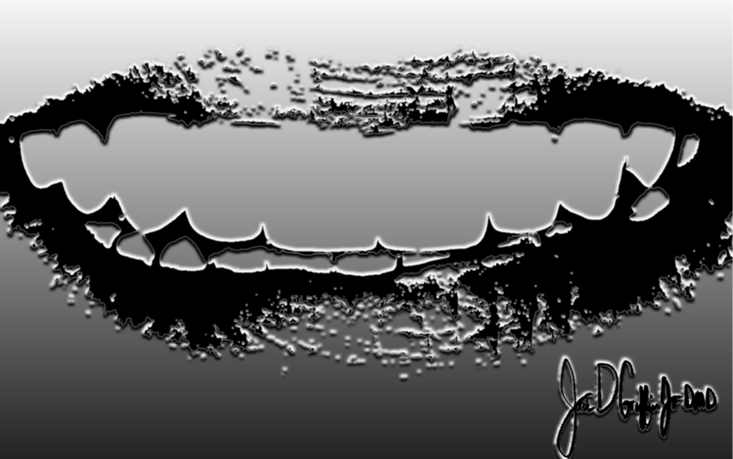
Jack D Griffin Jr DMD
314.488.1201
JGriffinJrDMD@gmail.com

